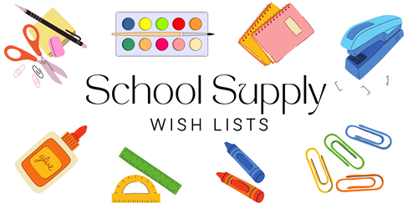

**KINDERGARTEN**

**24/25**

6 BOXES OF CRAYOLA CRAYONS (24ct)

1 BOX OF CRAYOLAWASHABLE WATERCOLORS 8 (PAINT)

1 BOX OF CRAYOLA MARKERS (FAT)

8 ELMERS GLUE STICKS (JUMBO)

1 BOX CRAYOLA COLRED PENCILS (24ct)

24 #2 TICONDEROGA PENCILS (SHARPENED)

3 MEAD MARBLE COMPOSITION BOOKS – ANY COLOR (100ct)

1 PRIMARY LINED COOMPOSITION NOTEBOOK – ANY COLOR

1 ZIPPERED PENCIL CASE

2 FISKARS BLUNT TIP 5” SCISSORS

3 PLASTIC POCKET FOLDERS WITH PRONGS (1 RED, 1 BLUE & 1 YELLOW)

1 WHITE VIEW VINYL BINDER 1.5”

1 ADJUSTABLE OVER THE HEAD HEADPHONES (NO EARBUDS)

2 PACKAGES BABY WIPES SOFT PACK (80ct)

2 REAMS COPY PAPER

3 PERMANENT SHARPIE MARKERS (BLACK)

1 BOX OF KLEENEX TISSUES

1 BOX OF QUART SIZE ZIPLOCK BAGS (BOYS ONLY)

1 BOX OF GALLON SIZE ZIPLOCK BAGS (GIRLS ONLY)

4 BLACK EXPO DRY ERASE FINE TIP MARKERS (BOYS ONLY)

4 MULTI-COLOR EXPO DRY ERASE CHISEL TIP MARKERS (GIRLS ONLY)

1 PACK REGULAR SIZE PLAIN PAPER PLATES (BOYS ONLY)

1 PACK SMALL SIZE PLAIN PAPER PLATES (GIRLS ONLY)

2 LANYARDS WITH ID HOLDER

1 PACKAGE 50 COUNT PAGE PROTECTORS